Background

Every company who need to export meats to other countries they need to have Health Certificate to their Meats. Providing certificate is the main task of the well-known Australian company which is named AQIS (Australian Quarantine Inspection Service). Every Company who need to export Food items, they have to request for the Health certificate. So there are large amount of companies who do same work. In case, large amount of documentation has been handled by AQIS. So then it will be the hard work to them. So then they need to automate their system. But still they handle small systems such as
- Payroll system
- Log in system
With above problem they have faced with some problems. Those are
- Hard to handle large amount of data
- Hard to communicate with Exporter and Destination country.
- Big problem of protecting documentation
- Large work base is needed to handle documentation
- It is need time for verify giving details of exporter. But it will be the problem to them because time is the major fact of export meat.
- Manual system will make workers tired.
According to our client‘s (AQIS) requirements we should automated their entire system. With the system it will gain a lot of advantages to them such as,
- Exporters can connect with AQIS via their User profile (If they registered with AQIS, Profile is allocated to them).
- No large amount of documentation Exporters can request from the system and system will validate the given detail of them.
- No need to handle large amount of work base. But need to keep Health inspectors. (HI is must handled in previous system also).
- AQIS can log into the exporters’ profile and can give feedbacks, Special notices so on.
- Electronic mails are very easily sent with the system.
With the Automated system they can handle and work with the client very easily. So this System will help them as much as it can to complete the tasks in very short time period.

Functional Requirements

F1 : Request the permission.
Input : Product details, Slaughter date, Abattoir and Destination Country.
Output : Notification.
Process : Send the request to AQIS and store the same request in database.

F2 : Give HC (Health Certificate) and Expiry date.
Input : Exporters documentation and endorsement of inspector.
Output : Valid HC and expiry date.
Process : Approve and inspect of the lodgment

F3 : Print HC.
Input : HC and expiry date.
Output : Printed HC.
Process : Soft copy of HC will send to printer.

F4 : Send error message.
Input : HC and expiry date.
Output : EDI Message.
Process : Generate the EDI message and forward it.

F5 : View the HC.
Input : EDI message.
Output : viewed HC,
Process : View the HC.

F6 : Notify the status.
Input : EDI message, comments about shipment.
Output : Status about the shipment.
Process : Compare both EDI message and comment, then generate the status.

F7 : Cancel the HC.
Input : LQC's status.
Output : Cancel the HC.
Process : Compare LQC's status and HC.

F8 : Give the endorsement.
Input : Lodgment of the RFP.
Output : Give the endorsement.
Process : Inspect the meat and documentation.

F9 : Login
Input : User name, Password
Output : Change login status and redirect to request for permit page.
Process : Validate the user.

Non functional requirements
- Exporter , AQIS, & LQA can be logged in to the same profile.
- English is used for every instruction and for communication.
- System respond to clients requests with in 30 seconds.

Constraints
- RFP should expire after 7 days
- Health certificate is must to export Meat
- Exporters given details must be validate
- Program should be written in java.
- Task should be completed with in 30 days.
- Everybody must log in before do works.

Assumptions
- Exporter, HI and LQA should log into the same profile before do task.
- Login is same to everybody who engages with same task.
- Health certificate should be exist until the good are expired if the LQA is accepted the shipment.
- Health certificate is automatically canceled when the receiving of LQA’s rejection feedback.
- Health Inspector can view the RFP while in task of giving endorsement.

Use Case Diagram

Use Case Scenario
- Use Case Name :- View the HC.
Precondition :- System is currently working.
Primary Actor :- LQC.
Main Flow :- 1) Include (Login).
2) Use Case Ends after loading HC page.
Extension :- -

- Use case name :- Request Permit.
Primary Actor :- Exporter.
Precondition :- System is currently working.
Main Flow :- 1) include (Login).
2) Use Case Ends when the User send the request to the System.
Extension :- -

- Use case name :- Rejection.
Primary Actor :- LQA (Local Quarantine Authority).
Precondition :- System is currently working & User must be logged in.
Main Flow :- 1) Include (Login).
2) Use Case Ends when the HC is cancelled.
Extension :- -

- Use case name :- Cancel HC.
Primary Actor :- -
Precondition :- System is currently working & User must be Logged in.
Main Flow :- 1) Use case begins when the Verify the status set as rejected.
2) Use case ends when the HC is deleted from the Data Base.
Extension :- -

- Use case name :- Login.
Primary Actor :- HI, Exporter, LQA.
Precondition :- System is currently working.
Main Flow :- 1) Use Case begins when the user try to view the pages of system.
2) Enter Username & Password.
3) Read Username & Password.
4) Validate Username & Password.
5) Use Case ends when the acknowledgment is received.
Extension :- 4. a) i) Invalid Username or Password.
ii) Perform Step 2.

Activity Diagrams
- Request the permit

- Cancel HC

- Notify the status

- Send EDI Message

- Give the Endorsement

Data Flow Diagrams
- Context diagram

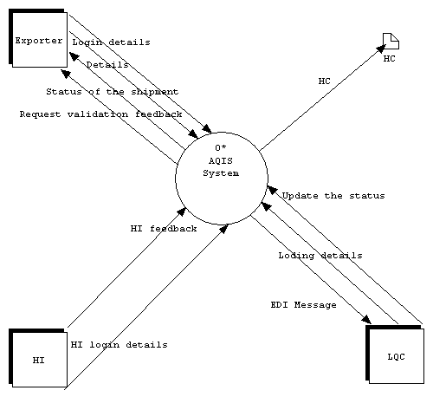

- Level 1 DFD
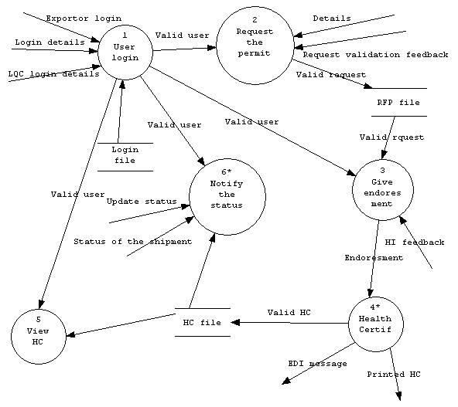

HI

Shipment status

- Level 2 DFD

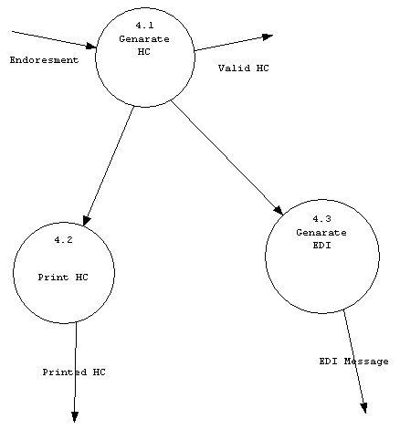

- Level 2 DFD

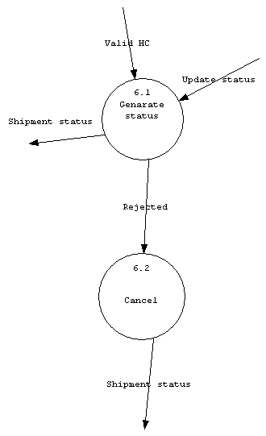
Valid user

Data Dictionary

- HI Login detail = User Name + Password
- LQA login detail = User Name + Password
- Exporter login=User Name + Password
- Detail = slaughter date + abattoir + destination country + product description
- Request Validation Feedback = [Accept the request | Reject the request]
- Valid request = Accepted Request from AQIS
- Status of the Shipment = [Accept the shipment | reject the shipment]
- Shipment Status=[ Acceptation | Rejection ]

Structured Chart
Valid User
Valid User
Main
1
HC File
2
RFP File
3
Login File
Valid HC
Valid HC
Rejection
Rejection
1
1
Valid User
Valid User
Endorsement
Valid
User
Endorsement
Cancel
EDI Message
Update Status
1
Shipment Status
Generate Status
Generate EDI
Print HC
Generate Health Certificate
Detail
Request validation feedback
User Detail
HI Feedback
User login
Give Endorsement
Health Certificate
View HC
Notify the Status
Request the Permit
Valid HC
Valid request
2
3

